**Cover Page:**

Navy Blue Texture with Earth-Space



**Version 1:**

*The puzzle of apple falling from a tree has been long solved.*

*But the universe does not stop throwing more puzzles…*

*Where are you in this game of learning and solving?*



**Building Solid Foundations**

**Version 2:**

*Where are you in this game of learning and solving?*

*Logo…*

**First page:**

Images: Creative College Graduate, University, etc…

*Discover your academic potential!*

*Get Ready for College and More…*

Wake up and get your academic skills polished to discover more of your ability!

**Who Are We?**

TutorComp is the online tutoring company providing personalized 1-on-1 and group tutoring sessions to K-12 students and adult learners all across the world.

Our faculty are qualified educators from various nations having years of experience in the noble profession of teaching.

Our virtual platform gives remarkable access to students and educators to connect and explore the joy of learning in a smart technology enabled environment.

**Second Page:**

Images Idea:



**How We Do?**

We bring real-time classroom teaching in front of the student irrespective of time and location through our online whiteboard application.

Our whiteboard allows **clear audio-video calls for 1-on-1 and group sessions** in various subject courses, and thereby allows the student to connect with qualified educators from different parts of the world from the extreme comfort of their home.

Our smart environment features collaborative teaching tools meant to engage and capture student’s rapt attention, and supplements with **Homework and Practice Test modules.**

**Why We Do?**

To provide a place for students to release their academic fears and realize their learning ability.

**Next Page:**

Images: Calculations on sports, etc…

**Content:**

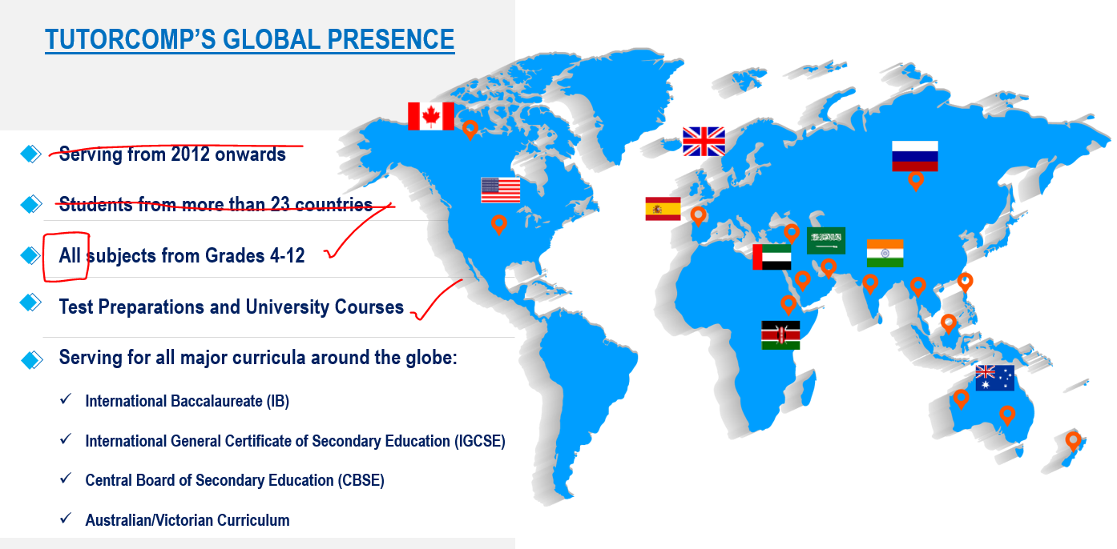

World Map running transparently on the backdrop of the pages with pointers as shown above.

**End Page:**

Tell us what you want and we will learn to offer.

Contact us at –

**Additional References:**

